

ETHICAL HACKING PRACTICAL REPORT
NAME:KELVIN MEIN
REG NO:BSCCS/2024/56078
UNIT: ETHICAL HACKING AND COUNTER MEASURES

WEEK-6: VULNERABILITY ASSESSMENT AND SCANNING 3
TASK 1: BASIC VULNERABILITY SCAN 3
Fig 1: Active Host Discovery Using Nmap 3
Fig 2: Open port identification and service enumeration using nmap 4
Observation (write this in report) 4
Recommendation 4
TASK 2 : VULNERABILITY RESEARCH ASSIGNMENT 5
TASK 3: ORGANISATIONAL VULNERABILITY PLAN 7
Scope: 7
Tools: 7
Schedule: 7
Reporting Procedure: 7
ADVANCED PRACTICAL TASK 8
VULNERABILITY TRACKING SPREADSHIT 8
CHALLENGE TASK 9
WEEK-6 STUDENT REFLECTION 10
WEEK-7 WEB APPLICATION SECURITY AND OWASP TOP 10 11
TASK ONE : OWASP TOP 10 RESEARCH 11
TASK TWO WEB APPLICATION ASSESSMENT 14
Fig 1: OWASP JUICE SHOP HOMEPAGE 15
Fig 2 : Forms identified 16
Fig 2:Authentication mechanism 18
Fig 3: Userroles 19
Fig 4: Potential vulnerabilities 21
TASK THREE: SECURITY IMPROVEMENT PROPOSAL 22
ADVANCED PRACTICAL TASK 23
WEB SECURITY CHECKLIST 23
WEEK-7 STUDENT REFLECTION 24

WEEK-6: VULNERABILITY ASSESSMENT AND SCANNING

TASK 1: BASIC VULNERABILITY SCAN

Fig 1: Active Host Discovery Using Nmap
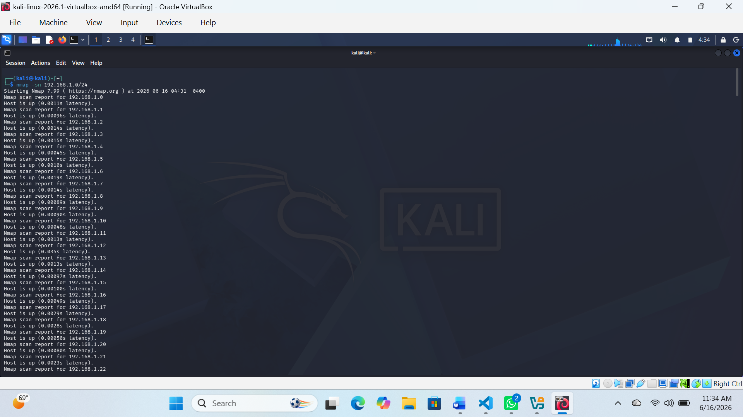
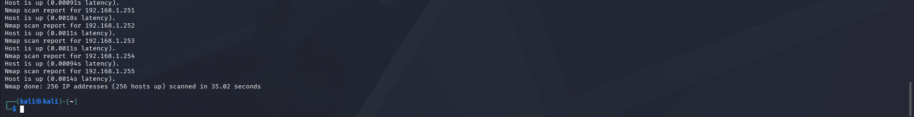
Observations
- Several active hosts were detected in the 192.168.1.0/24 network.
- The scan confirmed that multiple devices are reachable and responding.
- No port information was collected since this was a host discovery scan.
Recommendations
- Allow only authorized devices on the network.
- Regularly monitor connected hosts for unknown devices.
- Use network segmentation to improve security.
- Enable basic network monitoring to detect unauthorized access.

Fig 2: Open port identification and service enumeration using nmap
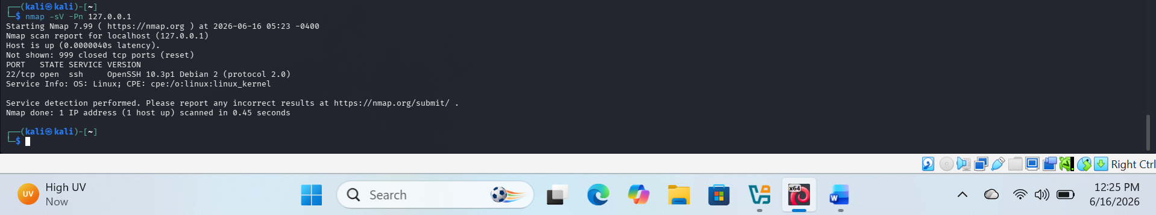

Observation (write this in report)
The scan of localhost (127.0.0.1) revealed that port 22/tcp is open and running the SSH service (OpenSSH 10.3p1). This confirms that the system is exposing a remote administration service.

Recommendation
SSH access should be secured using key-based authentication, firewall rules should restrict unauthorized access, and root login should be disabled to reduce attack surface.

TASK 2 : VULNERABILITY RESEARCH ASSIGNMENT
Research five recent vulnerabilities.
Include:
- CVE Number
- Description
- Severity
- Potential Impact
- Mitigation Strategy
They are:
1.XZ Utils Backdoor
- CVE Number:
  - CVE-2024-3094
- Description:
  - Malicious backdoor was introduced into XZ Utils compression library affecting Linux systems.
- Severity:
  - Critical
- Potential Impact:
  - Remote code execution, SSH compromise, full system takeover.
- Mitigation Strategy:
  - Downgrade to safe versions and apply security patches immediately.
2.Palo Alto PAN-OS Command Injection
- CVE Number:
  - CVE-2024-3400
- Description:
  - Command injection vulnerability in Palo Alto firewall software.
- Severity:
  - Critical
- Potential Impact:
  - Remote attackers can execute system commands with root privileges.
- Mitigation Strategy:
  - Apply security patches and restrict management interface access.

3.Ivanti Connect Secure Authentication Bypass
- CVE Number:
  - CVE-2024-21887
- Description:
  - Authentication bypass vulnerability in Ivanti VPN appliances.
- Severity:
  - Critical
- Potential Impact:
  - Unauthorized access to VPN systems and internal networks.
- Mitigation Strategy:
  - Apply updates and enforce multi-factor authentication.
3.Check Point Security Gateway Path Traversal
- CVE Number:
  - CVE-2024-24919
- Description:
  - Path traversal vulnerability in Check Point security products.
- Severity:
  - High
- Potential Impact:
  - Attackers can access sensitive system files and configurations.
- Mitigation Strategy:
  - Update firmware and restrict external access.
4.Apache ActiveMQ Deserialization RCE
- CVE Number:
  - CVE-2023-46604
- Description:
  - Deserialization vulnerability in Apache ActiveMQ allowing remote code execution.
- Severity:
  - Critical
- Potential Impact:
  - Full system compromise and unauthorized command execution.
- Mitigation Strategy:
  - Upgrade to patched versions and disable unsafe deserialization.

TASK 3: ORGANISATIONAL VULNERABILITY PLAN
Financial Institution

Scope:
- Online banking systems
- Internal banking applications
- ATMs and payment systems
- Databases containing financial records
- Network infrastructure

Tools:
- Nessus / Qualys
- SIEM tools
- Metasploit (controlled testing only)
- Nmap

Schedule:
- Weekly vulnerability scans
- Continuous real-time monitoring
- Quarterly penetration testing

Reporting Procedure:
- Immediate escalation of critical vulnerabilities
- Daily security operations center (SOC) reports
- Monthly compliance and audit reports to management and regulators

ADVANCED PRACTICAL TASK
Create a vulnerability tracking spreadsheet containing:
- Vulnerability Name
- Risk Level
- Status
- Assigned Personnel
- Resolution Date
- This simulates real-world vulnerability management processes

VULNERABILITY TRACKING SPREADSHIT

CHALLENGE TASK
Design a Vulnerability Management Framework for an organization.

ASSET INVENTORY
List of all systems, servers, and devices

VULNERABILITY SCANNING
Find security weaknesses in systems

RISK ASSESSMENT
Check severity (High , Medium , Low )

PATCH MANAGEMENT
Fix Vulnerabilities Using updates and patches

REPORTING
Send security reports to IT team and management

CONTINUOUS MONITORING
Ongoing monitoring for new threats

WEEK-6 STUDENT REFLECTION
This class helped me understand how vulnerability assessment works in real environments. I learned how to scan networks, identify open ports, and research CVEs. It also improved my knowledge of security planning for different organizations. Overall, it strengthened my awareness of cybersecurity risks and how to manage them effectively.

WEEK-7 WEB APPLICATION SECURITY AND OWASP TOP 10

TASK ONE : OWASP TOP 10 RESEARCH
Research all ten OWASP Top 10 vulnerabilities.
For each vulnerability provide:
- Definition
- Example
- Impact
- Prevention

1.Broken Access Control
Definition:
Occurs when users can act outside their intended permissions.
Example:
A normal user accessing admin pages by changing the URL.
Impact:
Data theft, privilege escalation, full system compromise.
Prevention:
Enforce role-based access control (RBAC), deny-by-default rules, server-side authorization checks.
2. Cryptographic Failures
Definition:
Weak or missing encryption protecting sensitive data.
Example:
Storing passwords in plain text.
Impact:
Data leaks, identity theft, financial loss.
Prevention:
Use strong encryption (AES), HTTPS, proper key management, hashing passwords (encrypt/argon2).
3. Injection
Definition:
Untrusted input is sent to a command or database.
Example:
SQL Injection: ' OR 1=1 -- used to bypass login.
Impact:
Data breach, data loss, remote code execution.
Prevention:
Use prepared statements, input validation, ORM frameworks.
4. Insecure Design
Definition:
Flaws in system architecture or design.
Example:
An app that allows unlimited password attempts without lockout.
Impact:
Easy exploitation even if code is secure.
Prevention:
Threat modeling, secure design principles, rate limiting, security requirements.
5. Security Misconfiguration
Definition:
Improper configuration of servers, apps, or databases.
Example:
Leaving default admin passwords active.
Impact:
Unauthorized access, data exposure.
Prevention:
Secure configuration baselines, disable unused features, regular audits.
6. Vulnerable and Outdated Components
Definition:
Using libraries or software with known vulnerabilities.
Example:
Using an outdated version of a framework with known exploits.
Impact:
System compromise through known exploits.
Prevention:
Regular updates, dependency scanning, patch management.
7. Identification and Authentication Failures
Definition:
Weak login and session management.
Example:
No multi-factor authentication (MFA), weak passwords.
Impact:
Account takeover, identity theft.
Prevention:
MFA, strong password policies, secure session handling.
8. Software and Data Integrity Failures
Definition:
Software or data is not protected from unauthorized modification.
Example:
Using unverified software updates from third-party sources.
Impact:
Malware injection, system compromise.
Prevention:
Code signing, integrity checks, secure CI/CD pipelines.
9. Security Logging and Monitoring Failures
Definition:
Lack of proper logging and incident detection.
Example:
Failed login attempts not recorded.
Impact:
Attacks go undetected, delayed response.
Prevention:
Centralized logging, real-time monitoring, alert systems.
10. Server-Side Request Forgery (SSRF)
Definition:
Attacker forces server to make requests to internal or external systems.
Example:
A URL input makes server access internal admin panel.
Impact:
Data exposure, internal network attacks.
Prevention:
Validate URLs, block internal IP ranges, allowlist external requests.

TASK TWO WEB APPLICATION ASSESSMENT
Select a legal practice application lab environment
Identify:
- Forms
- Authentication mechanism
- User roles
- Potential vulnerabilities

Fig 1: OWASP JUICE SHOP HOMEPAGE
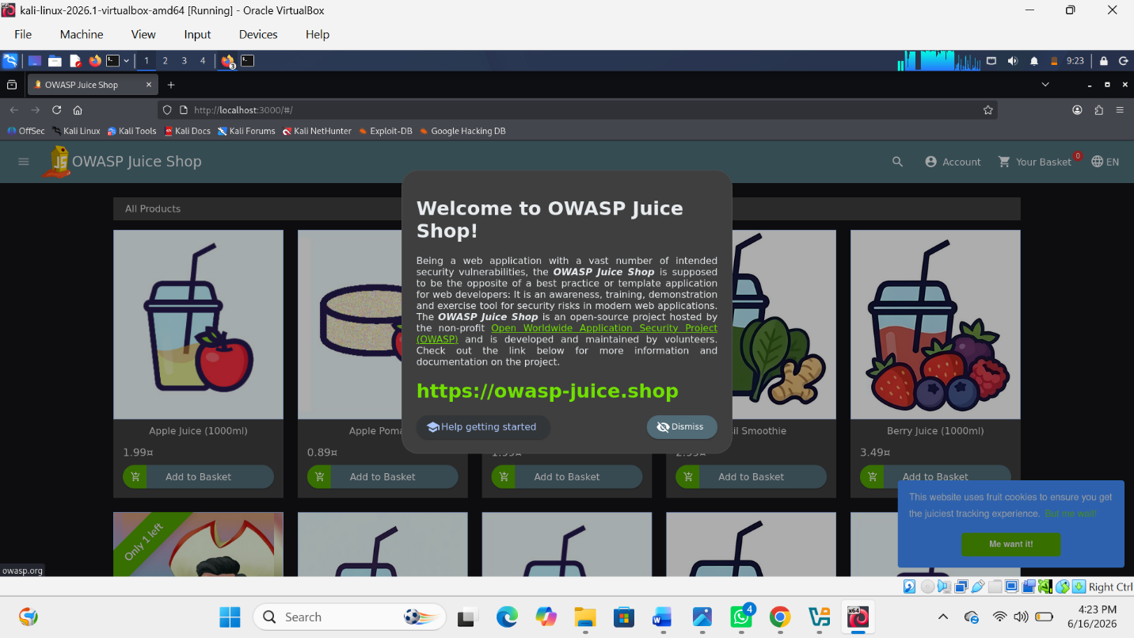

Fig 2 : Forms identified
1.Log in form
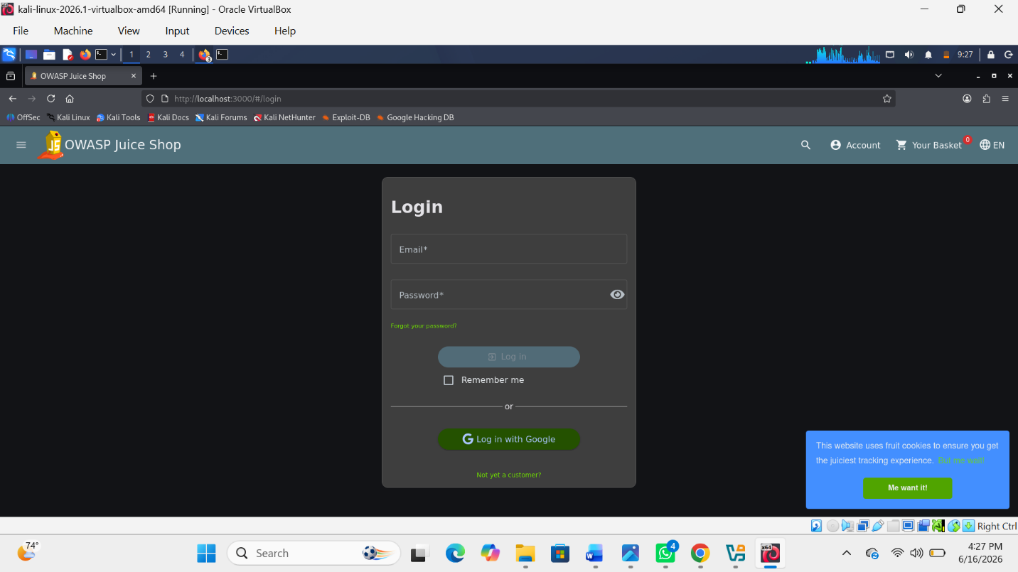

2. Registration form
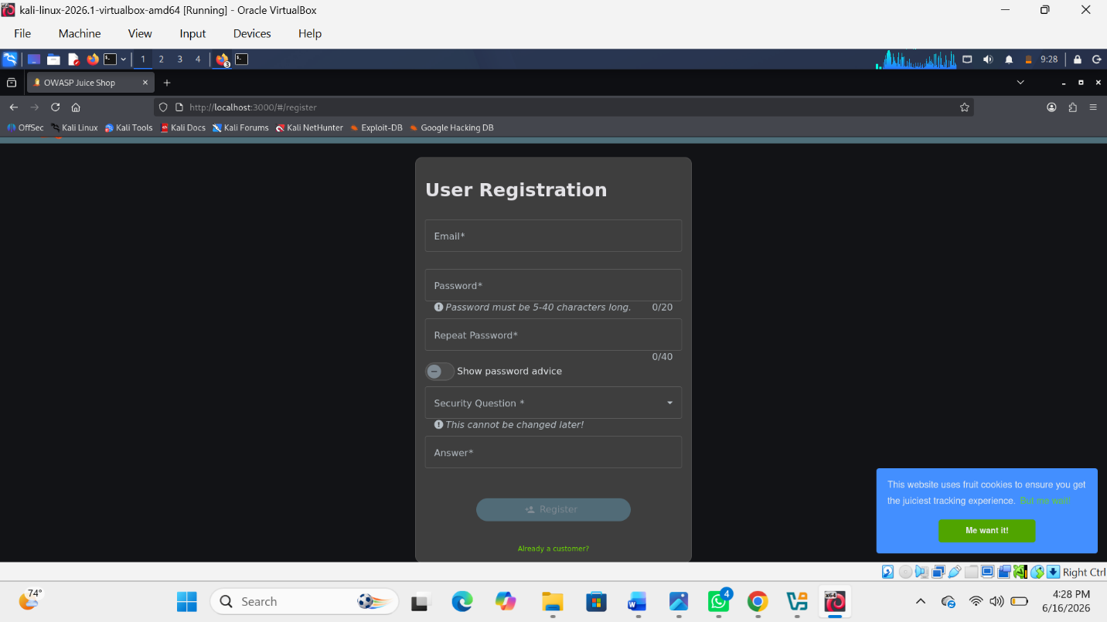

Fig 2:Authentication mechanism
1.Email and password authentication
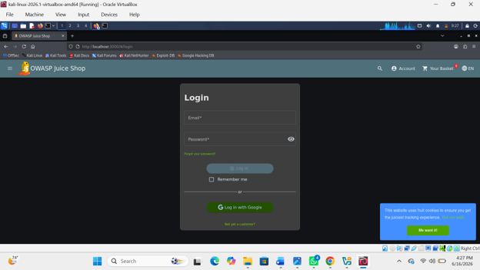

Fig 3: Userroles
1.Guest user
These are users who aren’t log and can access products but have no specific account
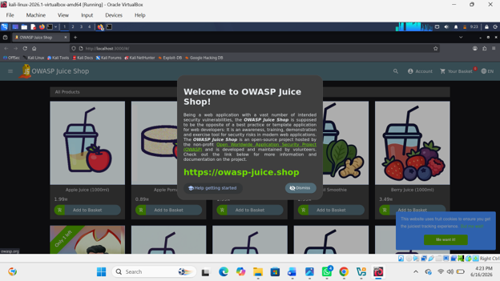

2.Registered user
These are users who have account
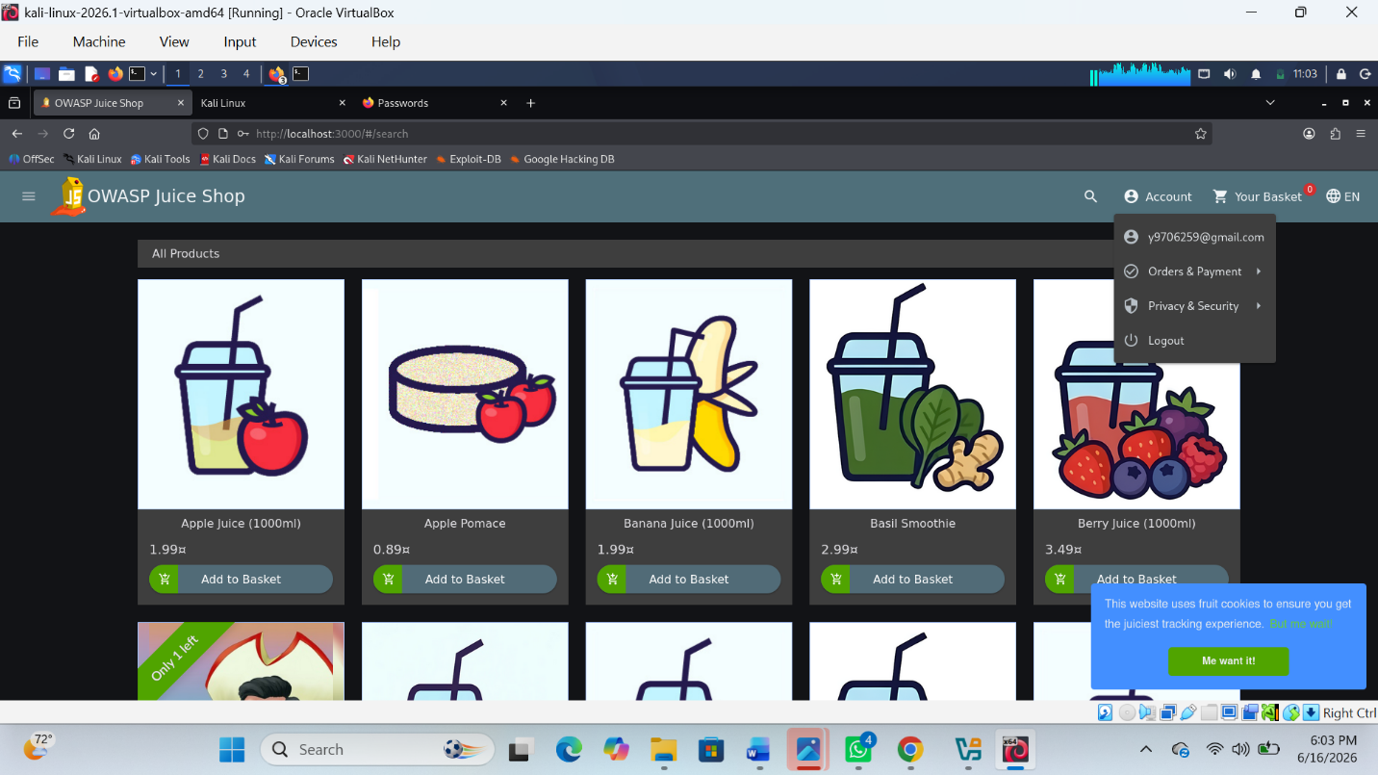

Fig 4: Potential vulnerabilities
1.Cross site scripting
XSS Test results
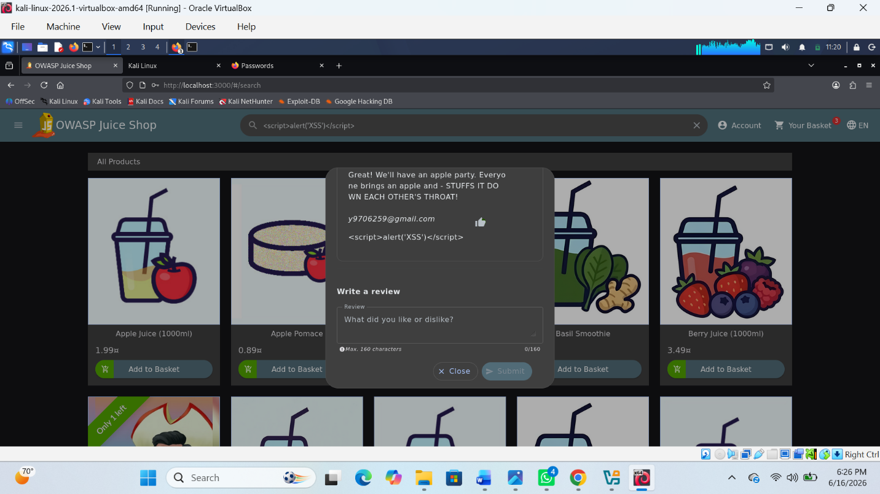

TASK THREE: SECURITY IMPROVEMENT PROPOSAL
Security Improvement Plan for a Web Application:
1. Authentication Controls
- Enforce strong password policies (minimum 8–12 characters with complexity requirements).
- Implement Multi-Factor Authentication (MFA) for all users.
- Use secure password hashing algorithms such as bcrypt or Argon2.
- Apply account lockout mechanisms after multiple failed login attempts.
- Manage user sessions securely with automatic session expiration.
2. Input Validation Measures
- Validate all user inputs on both client and server sides.
- Use parameterized queries and prepared statements to prevent SQL Injection.
- Sanitize user inputs to prevent Cross-Site Scripting (XSS).
- Restrict file uploads by checking file types, sizes, and content.
- Implement input length and format validation.
3. Logging Mechanisms
- Log authentication events such as logins, logouts, and failed attempts.
- Record critical system activities and administrative actions.
- Monitor and log suspicious activities and security violations.
- Store logs securely and protect them from unauthorized access.
- Regularly review and analyze logs for security incidents.
4. Patch Management Strategy
- Maintain an inventory of all software and system components.
- Monitor vendor security advisories and vulnerability notifications.
- Test patches in a staging environment before deployment.
- Apply critical security patches immediately after validation.
- Schedule regular updates for operating systems, web servers, and applications.
- Verify successful patch installation and maintain patch records

ADVANCED PRACTICAL TASK
Create a Web Security Checklist covering:
Categories
- Authentication
- Authorization
- Input Validation
- Session Management
- Encryption
- Logging
- Configuration Management

WEB SECURITY CHECKLIST
1. Authentication
- Strong password policy enforced
- Multi-Factor Authentication (MFA) enabled
- Passwords stored using secure hashing (bcrypt/Argon2)
- Account lockout after multiple failed login attempts
- Session timeout implemented
2. Authorization
- Role-Based Access Control (RBAC) implemented
- Users can only access allowed resources
- Admin privileges restricted
- Server-side authorization checks enforced
- Prevention of privilege escalation
3. Input Validation
- Server-side input validation enabled
- Input sanitization implemented (XSS protection)
- Parameterized queries used (SQL injection prevention)
- File uploads restricted (type/size check)
- Email and form validation applied
4. Session Management
- Secure session IDs generated
- Sessions expire after inactivity
- Logout destroys session
- Cookies set to Secure, HttpOnly, SameSite
- Session fixation protection enabled
5. Encryption
- HTTPS (TLS) enforced
- Sensitive data encrypted at rest
- Strong encryption algorithms used (AES-256)
- No sensitive data in URLs
- Secure key management implemented
6. Logging
- Login attempts logged
- Failed authentication attempts recorded
- Admin activities logged
- Logs include timestamp and IP address
- Logs protected from unauthorized access
7. Configuration Management
- Default settings removed
- Unused services disabled
- Security headers enabled (CSP, HSTS)
- Debug mode disabled in production
- Regular updates and patching applied

WEEK-7 STUDENT REFLECTION
This practical improved my understanding of common web application security risks and how they affect real systems. I learned how OWASP Top 10 vulnerabilities occur, how to identify weaknesses in applications, and how to propose security improvements. It also strengthened my skills in assessing, documenting, and planning secure web solutions.

